**Deadline Team Process**

Admission system

Contents

**Revision history** 2

**List of table** 2

**1.** **Introduction** 2

• **Purpose** 2

• **Goal** 3

**2.** **Development Model** 3

• Scrum model 3

• Scrum description 3

• Scrum model combine ACDM 4

**3.** **Role and responsibilities** 4

• Responsibilities 4

• Role 5

# **Revision history**

|  |  |  |  |
| --- | --- | --- | --- |
| **Version** | **Updated Date** | **Author** | **Description** |
| 1.0 | 11/19/2013 | Ta Ngoc Thien Phu | Create document |

# **List of table**

Table 1: Model Description 3

Bảng 2: Scrum combine ACDM 4

Table 3 Responsibilities 5

Table 4 Role 5

# **Introduction**

## **Purpose**

* This purpose of this document is show steps by steps that team have to comply to develop Admission System Project.

## **Goal**

* All members can understand about Development Model.
* Each members can understand roles in Development Model.
* Each members join to each role.

# **Development Model**

## Scrum model

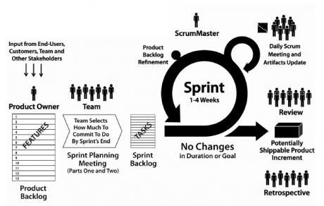

## Scrum description

|  |  |  |
| --- | --- | --- |
| **No** | **Phase** | **Description** |
| 1 | Develop stories | Get user stories that required from customer, data have to high level  This phase, requirement engineer only collect data from customer, not analyze |
| 2 | Create product backlog | Use data that collect from phase 1, synthesis user stories to create product backlog |
| 3 | Prioritize product backlog | Prioritize each items in product backlog |
| 4 | Sprint planning meeting | Define sprints, each sprint only have 2-4 week to implement  Planning for each sprint  Review sprint after completed sprint plan |
| 5 | Implement sprint | Sprint will produce about 2-4 week and No change in duration or Goal |
| 6 | Daily meeting | Development Team will meeting daily to report progress of each member and give difficult during develop this sprint |
| 7 | Shippable product increment | After completed sprint, integrate sprint that just been implement finished to system |

*Table 1: Model Description*

## Scrum model combine ACDM

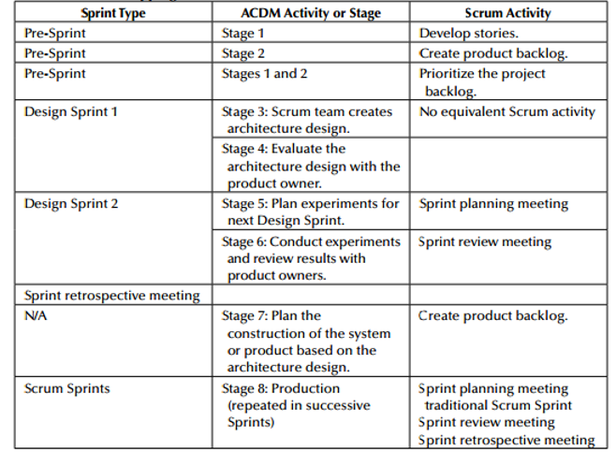

*Bảng 2: Scrum combine ACDM*

# **Role and responsibilities**

## Responsibilities

|  |  |  |
| --- | --- | --- |
| **No** | **Roles** | **Responsibilities** |
| 1 | Scrum Master | • Research techniques to manage the Product Backlog efficiently;  • Communicate with development team about vision, purpose, and the Product Backlog items;  • Training for Development Team how to create the Product Backlog items are clear and simple;  • Understand the long-term plan of products in a test environment;  • Understand and flexibility practice  • Promote the Scrum events as required or as needed. |
| 2 | Product owner | • Define product backlog items (features, patches, etc.)  • Decide release day and content  • Arrange items in the Product Backlog (PBI) to optimize the objectives and tasks-Responsibilities to optimize profit (ROI)  • Accept or reject work results  • Participate actively in the development process  • Have to a vision for product |
| 3 | Development Team | Don’t have clearly role (tester, programmer, designer)  Implement sprint that able to release  Maintain Sprint backlog frequently |
| 4 | Managing engineer: | The managing engineer is responsible for coordinating the overall system design and development effort. Although they are responsible for the success (or failure) of the design team, they must also be able to listen to other members of the design team |
| 5 | Support engineer | The support engineer is responsible for setting up and maintaining the design team’s support tools and environments, such as development environments and tools, configuration management tools, test environments and testing tools |
| 6 | Chief architect | The chief architect is responsible for overall system design. He or she will work with all of the other members of the design team to coordinate the system design, beginning with gathering the architectural drivers, designing the architecture, reviewing it, refining it, and documenting it until production and deployment—preferably throughout the system or product life cycle |
| 7 | Requirements engineer | The requirements engineer leads the effort to gather and document the architectural drivers. He or she will also help to manage the change and evolution of the architectural drivers—preferably throughout the system or product life cycle |
| 8 | Chief scientist | The chief scientist is the project technologist and is primarily responsible for coordinating the planning, tracking, and documentation of experiments that are used to refine the architecture design |
| 9 | Quality process engineer | The quality process engineer ensures that ACDM and other defined processes are followed as prescribed to ascertain project quality goals are met. The quality process engineer is responsible for coordinating architecture design reviews as well as product test development, planning, and execution |
| 10 | Production engineers | These are team members whose focus is on detailed design, implementation of the architectural elements, and integration of the elements to compose the system |

*Table 3 Responsibilities*

## Role

|  |  |  |
| --- | --- | --- |
| **No** | **Roles** | **Members applied** |
| 1 | Scrum Master | Chau Le |
| 2 | Product owner | Khang Huynh |
| 3 | Development Team | All team |
| 4 | Managing engineer: | Chau Le |
| 5 | Support engineer | Huy Ngo |
| 6 | Chief architect | Phu Ta |
| 7 | Requirements engineer | Khang Huynh |
| 8 | Chief scientist | Dao Khau |
| 9 | Quality process engineer | Huy Nguyen |
| 10 | Production engineers | All team |

*Table 4 Role*